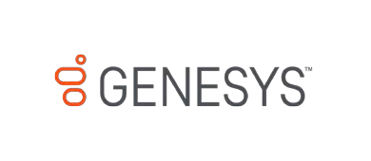

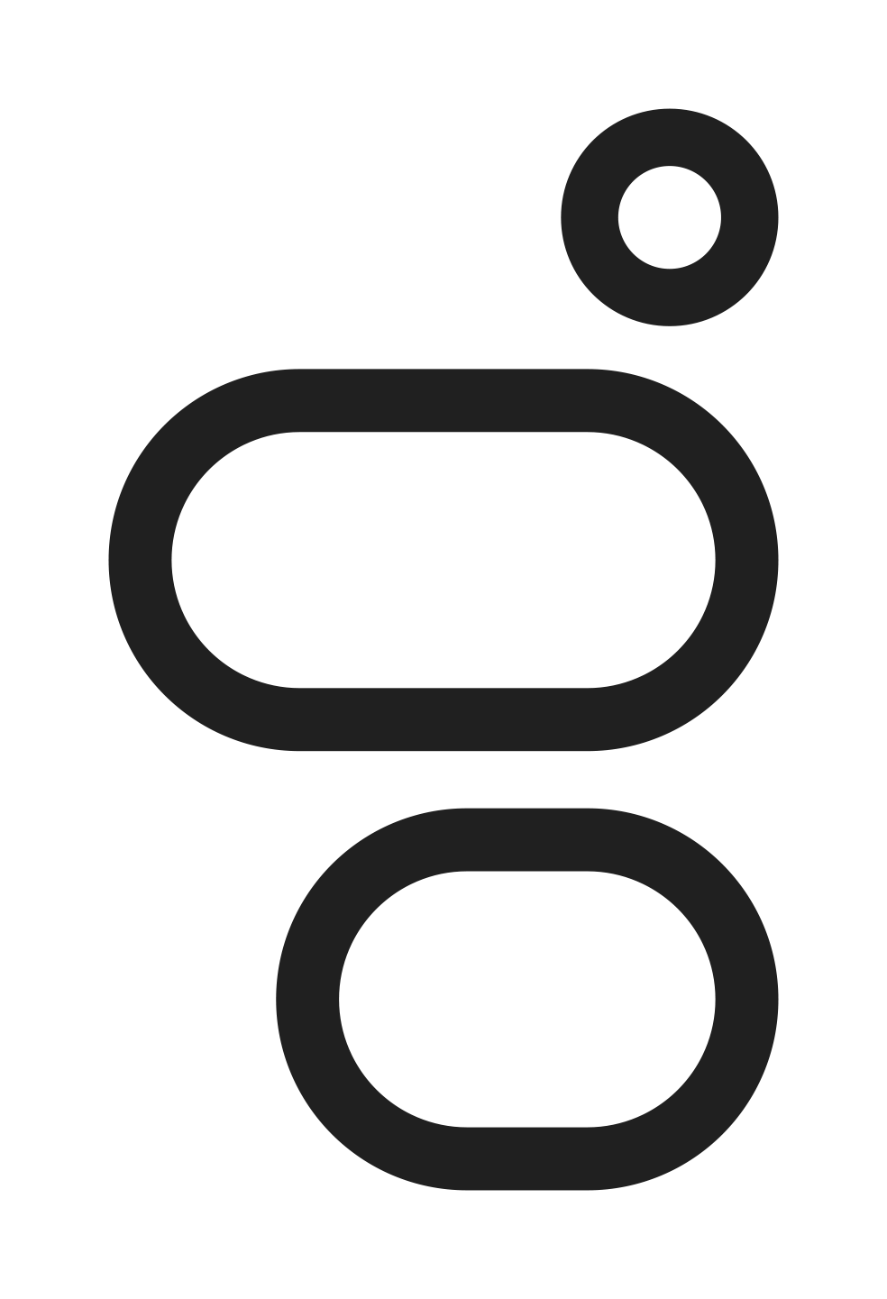
Genesys Cloud for WhatsApp Messaging
Customer Application for Migration

Getting Started with Genesys Cloud for WhatsApp Messaging

Please read, complete, and return the Customer Application on the next page to:
GenesysCloudWhatsAppRequests@genesys.com.

Customers must be approved by Facebook (who owns WhatsApp) to use the WhatsApp Business API platform. Approval is subject to guidelines in the Commerce Policy for WhatsApp and WhatsApp Business Policy. Please ensure your business use-case is aligned with these policies. Genesys will own and manage the WhatsApp Business Account (WABA) for customers. Customers must provide a valid Facebook Business Manager ID to begin the process. The Business Manager ID must match the Business Manager ID used with your Service Provider before the migration.

The most important immediate information is:

- Facebook Business Manager ID
See link here and image below for help finding this ID.
See page here to create a Business Manager if you do not have an existing BM.
- Business Name
This will be the name of your WABA (WhatsApp Business Account). The name should be the same (or similar) to your Business Manager name. This will expedite the review and approval process.

Please note, the Business Manager must be owned by the Brand that will interact with WhatsApp end-users. For example, a Business Manager owned by a Partner, Integrator, or Ad Agency cannot be accepted for customers.

WhatsApp Pricing for Genesys Cloud
Please see the Genesys Cloud Resource Center for additional information and for WhatsApp pricing details:
https://help.mypurecloud.com/articles/configure-acd-messaging-for-whatsapp/
https://help.mypurecloud.com/articles/acd-messaging-pricing/

Customer Application
Company Legal Name
Company Legal Address (including Country)
Company URL
Genesys Cloud Org ID

Genesys Cloud Region
Customer Facebook Business Manager ID (see here)
Customer Facebook Business Manager Name
Migrating From (Service Provider name)
WhatsApp Phone Number(s) to be migrated (include country code)
Is this number currently connected and functional on WhatsApp?
Owner Verification Method, see below (Voice or SMS)

Before Migration Can Begin
You must verify with your current Service Provider that Two-Step Verification is disabled on the WhatsApp number being migrated.

Migration Impact on WhatsApp Traffic
The migration process can occur without impacting the current traffic of the number. Once the migration is complete, Genesys will send you the instructions to complete the activation within Genesys Cloud. As you activate the WhatsApp integration in Genesys Cloud, existing traffic will come to a halt and new traffic will be directed through Genesys Cloud. Be sure to verify your integration’s Message Routing is configured as desired in order to have this new traffic routed correctly.

WhatsApp Phone Number Requirements and Owner Verification
- The phone number can be any valid landline or mobile number owned by the customer and currently in use with the WhatsApp Business API.
  - The number must receive a phone call or SMS message to receive a verification code. Please verify your preference in the form above. This step is required to verify ownership of the number.
  - This number cannot route to an IVR during this process. You must temporarily re-route it so the SMS message or phone call can be immediately received by a human. During the migration, this verification code will be delivered during Eastern US working hours.
- Once activated, the number can be re-routed back to your IVR (if applicable) or disconnected from voice / SMS service. If you choose to disconnect it, you must retain ownership of the number.

